|  |  |  |  |  |
| --- | --- | --- | --- | --- |
| Woodend’s guide to in the moment planning. As from September 2021, Woodend nursery will be making the transition from adult let planning, to in the moment planning. We are making this change with our children at the forefront of this decision, to hopefully make their experience here at nursery the best it can be. Why have we chosen planning in the moment? If children are allowed to choose how, where and with what they want to play with, they become invested in their play, and their learning and development comes on in leaps and bounds.  We are also trying to make changes to the amount of time we spend doing unnecessary paperwork or working on an iPad when we can use this time more freely to be interacting with our children, at on their terms. What happens during play? Well, exactly that. The children have free choice on what they want to do. Staff will be around the children, observing, and responding to play when the child interacts with them.  The adult will listen, watch and wait. The waiting is the important part – if the child wants you to join in then they will make this clear, if not, we sit and watch, then move away. |  | In the moment planning. This is a brief explanation to what planning in the moment is, how we will implement it, and what we hope to achieve from it.  We will be keeping parents informed along the way of what will be happening within nursery and we hope you can share our excitement with these changes.  If you have any questions at all, please don’t hesitate to contact Kelly or Louise 01283 704555 woodendday@aol.com |  |  |
|  |  |  |
|  | | |
|  |

|  |  |  |  |  |
| --- | --- | --- | --- | --- |
|  |  | Anna Ephgrave The room leaders in nursery, were all very lucky to be able to go on an intensive training course with Anna, the brains behind planning in the moment, and why it works so well for learning and development within young children. Information sharing. We really do value the understanding you have about your child. Any information you can share with us during your child’s focus week, like significant events or milestones, will help us to plan for your child’s future development. |  | Our vision is that our children are happy and engaged during their time with us. |
|  |  |
| Focus children. Each week, each room will choose a few children (roughly 10% of the numbers on the register per age group) and this is known as the focus group. All staff will be observing this group of children throughout the week, and putting together a learning journey with all different findings from this time. We won’t be having a key worker system like we have in the past; each child will have a key worker who will solely be responsible for passing on the learning journey to parents after the focus week has finished. Each child will have a sheet at the start of their nursery week, which will be filled in during their focus week. The staff in each room will add on their observations, and then the teaching that came from these observations, so you can clearly see how the staff have developed the child with immediate next steps. | Focus week You will be notified when it is your child’s turn for their focus week. The staff in each room, will all be observing your child – rather than just one specific key worker. Once the focus week is over for your child, you will be given feedback from what we have observed during that week. The feedback is something we aim to work on, to how we give this to you, possibly with a small parents evening, in nursery or over the phone, or we can upload it via our app. This is something we can be flexible with, to what suits you best on how we deliver this information to you. We will be asking you for information on your child before their focus week, such as any special events.Wow moments.   We will also be recording wow moments. This will be when a staff member has observed your child doing something independently for the first time. Please keep us up to date with any of these wow moments from home. Communication with Parents.  You may receive a lot of information over the coming weeks, if anyone has any questions the please feel free to get in touch with your child’s key worker, or send an email to the nursery email address. The different groups will issue the children with key workers, and will let parents know who they have been allocated. |
|  |
|  |

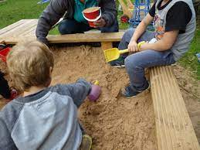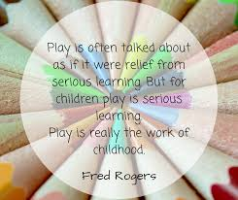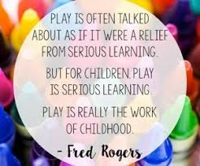

**Outside Play**

As many of you know, we love to spend as much time as we can outside! This doesn’t change within the moment planning! We will have our set areas outside too, such as a climbing area, sand and water, blocks and our great loose parts area.  
We keep indoors and outdoors separate, as outside is louder and messier, than the calm environment we will aim for inside!  
We will have a free flow policy throughout so any child can go outside if they wish.

**Our new environment.**We have had a total refurbishment   
throughout the whole nursery.  
We are very lucky to have had a specialist  
company come in, and design our rooms  
based on what we want ready for in the  
moment planning. We will be having set  
areas in each room, so the children will  
learn where all of their resources are  
and have the opportunity to play with  
whatever they wish. We have also had a   
big shopping spree for new toys and  
equipment, it is all very exciting!  
We will be having set areas, such as a   
new role play area, a creative area, a play  
dough station, sand and water.

.